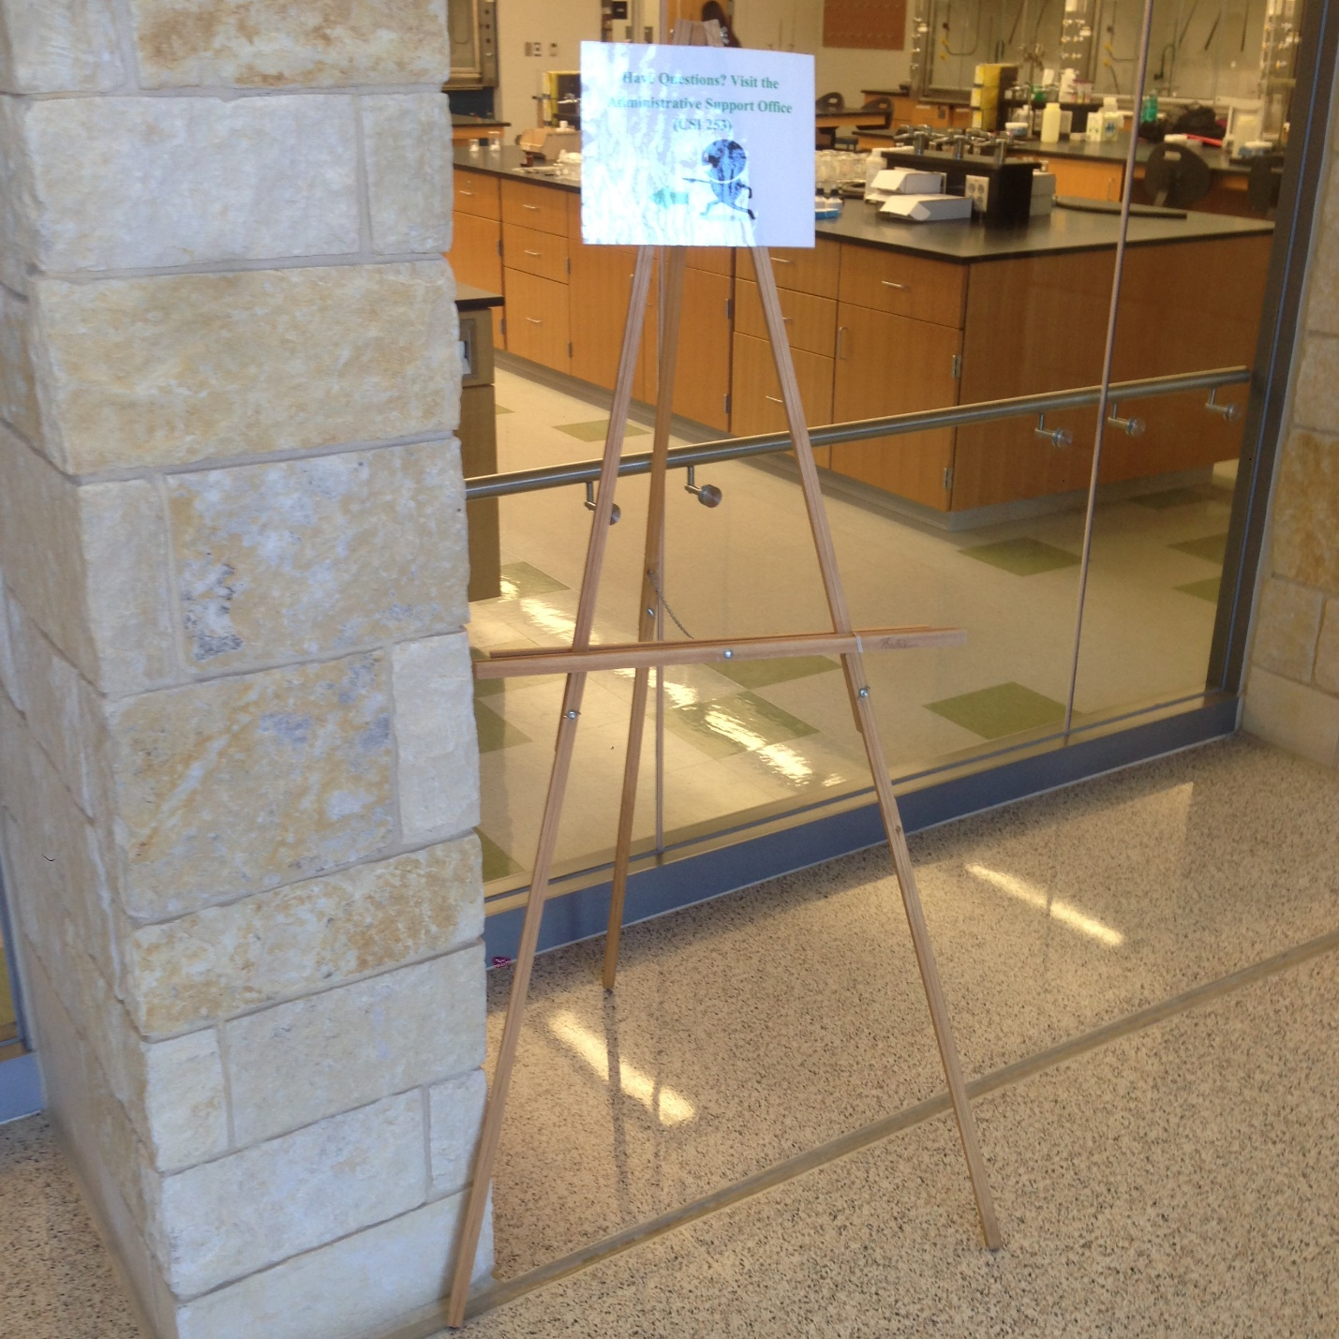

Figure 1. Idea for stands that can be strategically placed around CSI to allow for easy projection and visual experience for tourists.

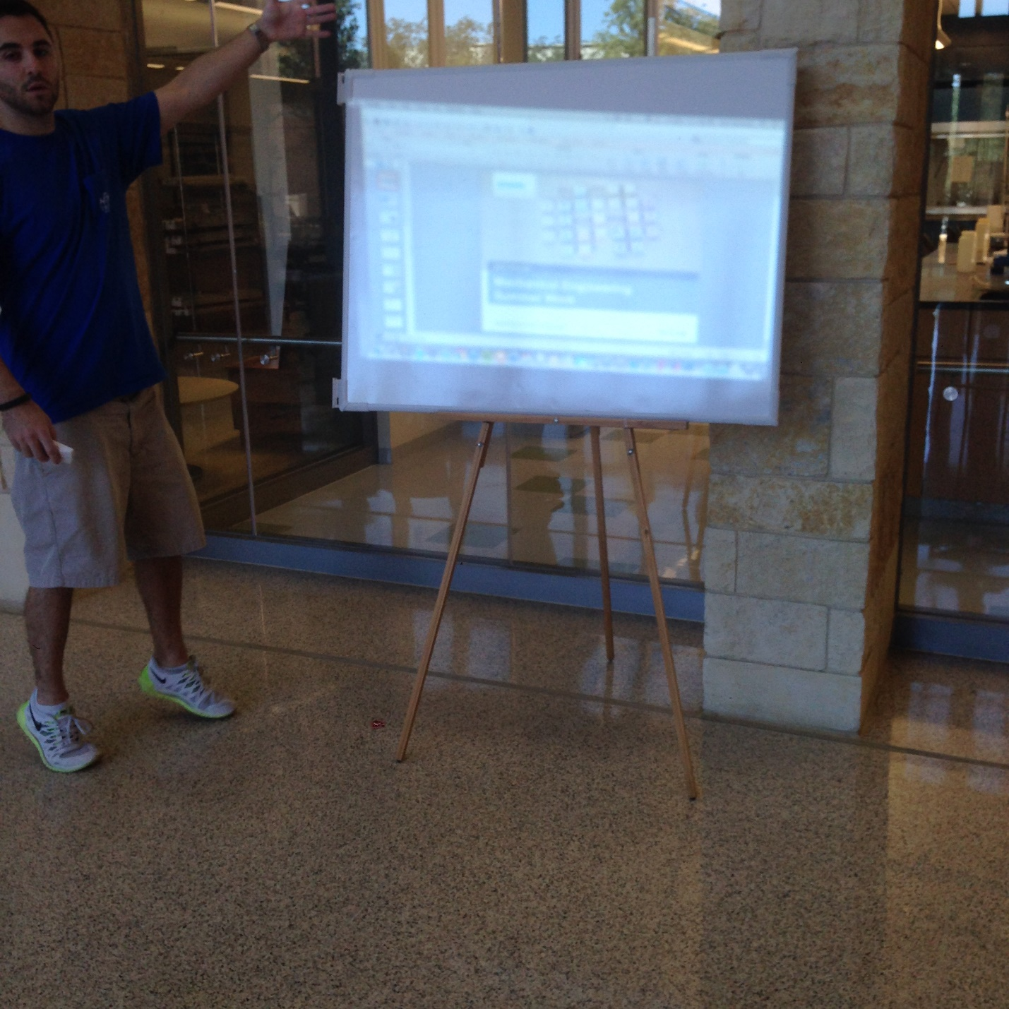

Figure 2. View to get a feel for the relative size of the board being used as a screen (Jack is on his tippy toes☺).

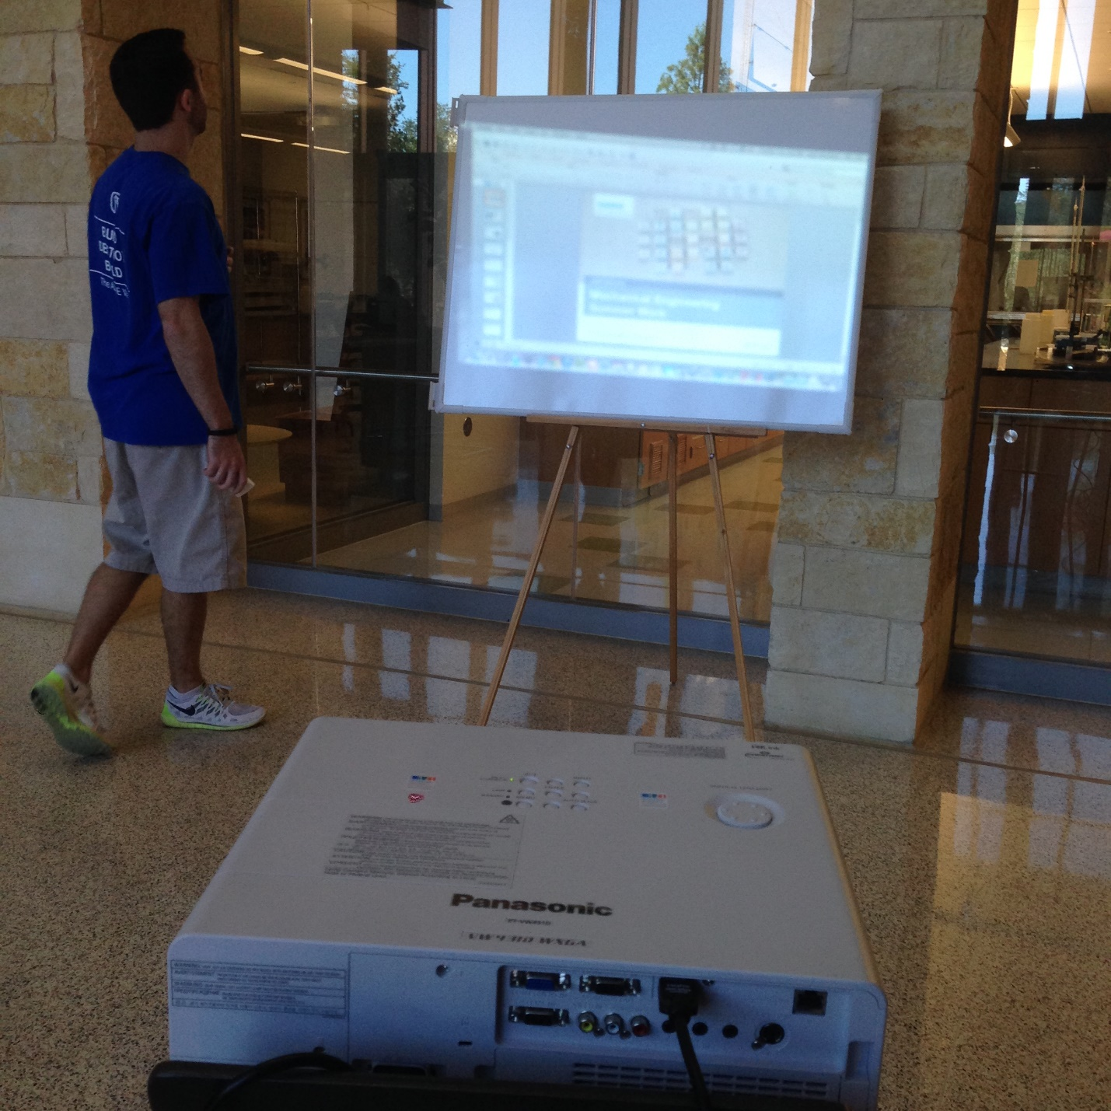

Figure 3. Jack with his back to us saying, “RUSH ASME!” Notice that because the keystone correction feature is ***not*** enabled, the screen appears distorted.

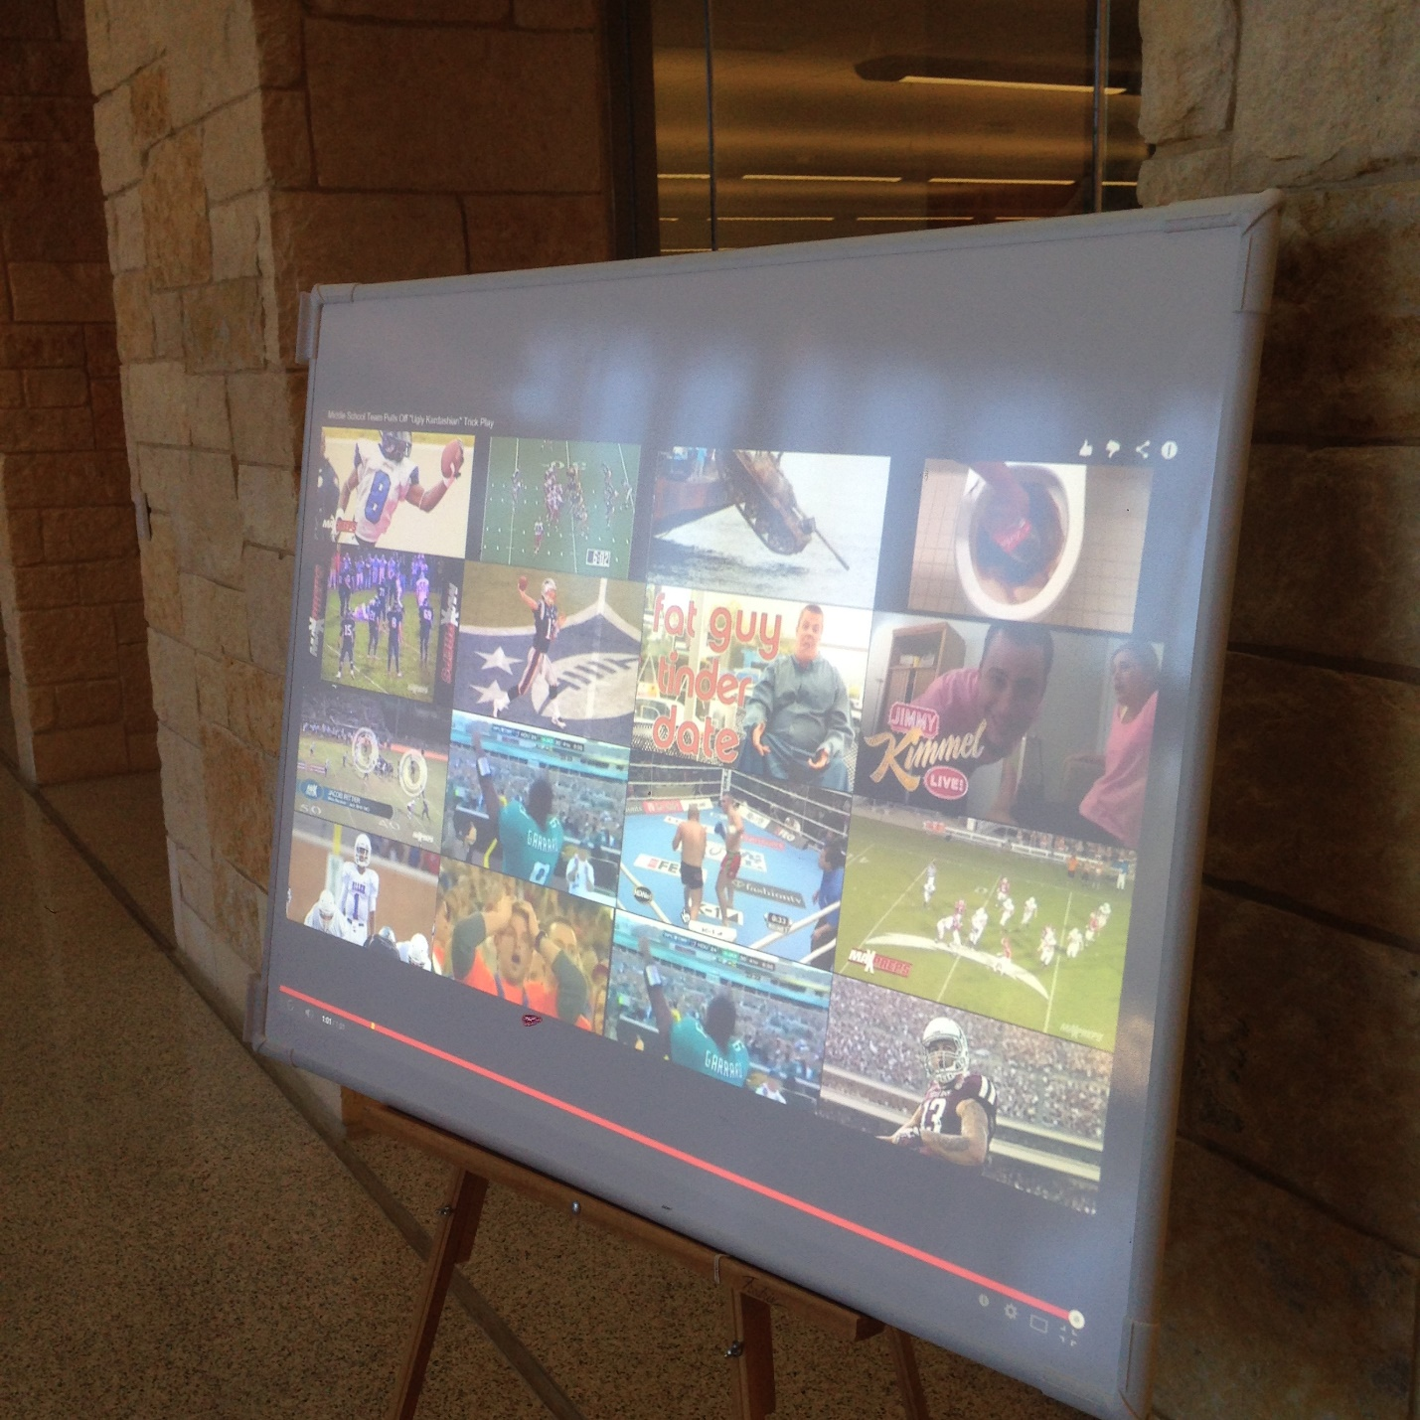

Figure 4. Visual of 4300 Lumen projector with noticeable glare that was tested in the bright atrium area of CSI 2nd floor with Keystone correction feature enabled.

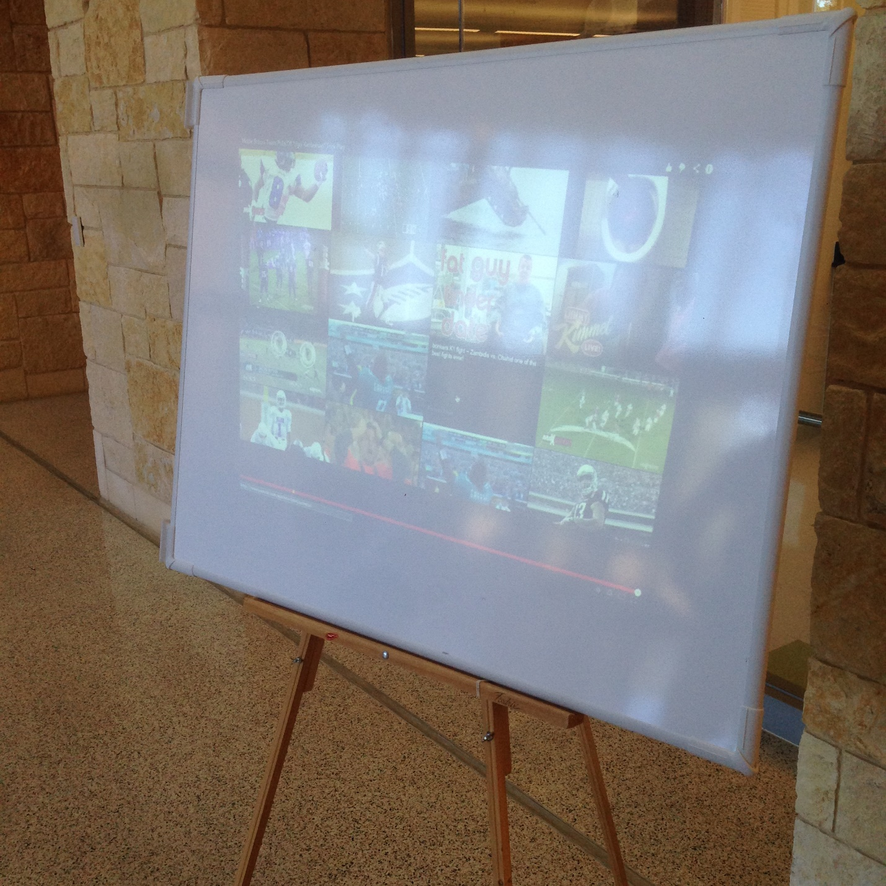

Figure 5. Visual of 900 Lumen projector with even more noticeable glare that was tested in the bright atrium area of CSI 2nd floor (dark background).

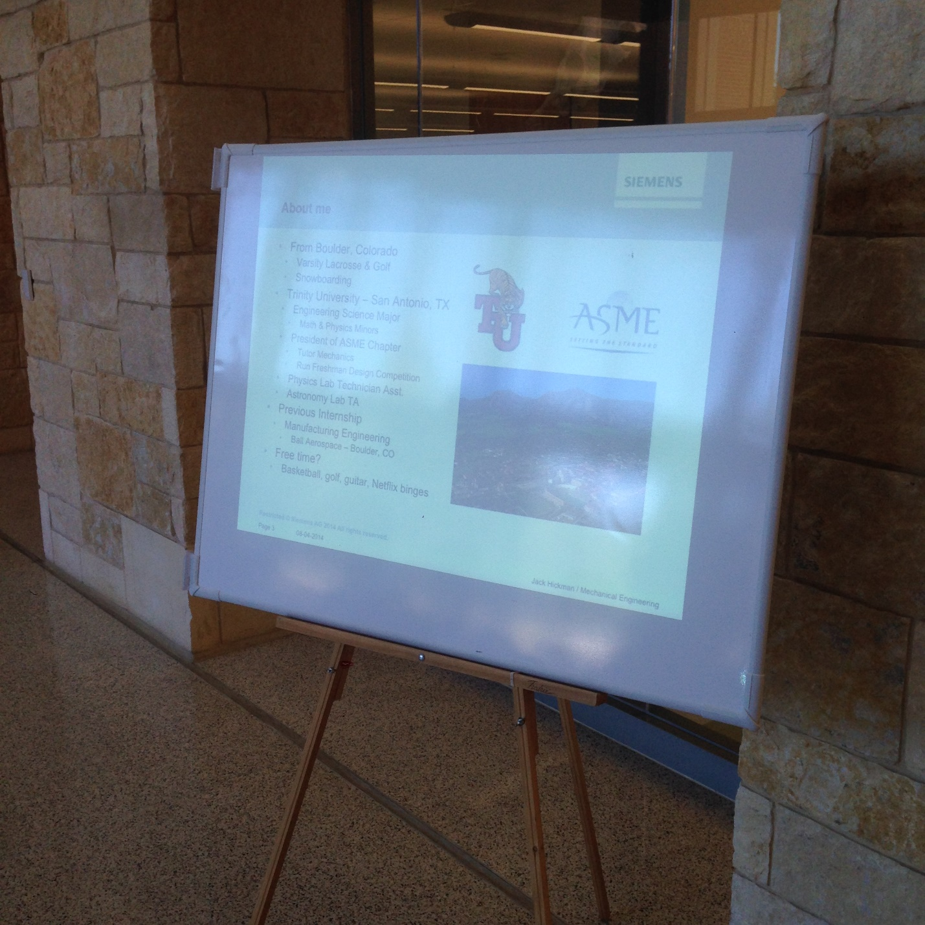

Figure 6. Visual of 900 Lumen projector with even more noticeable glare that was tested in the bright atrium area of CSI 2nd floor (white background).

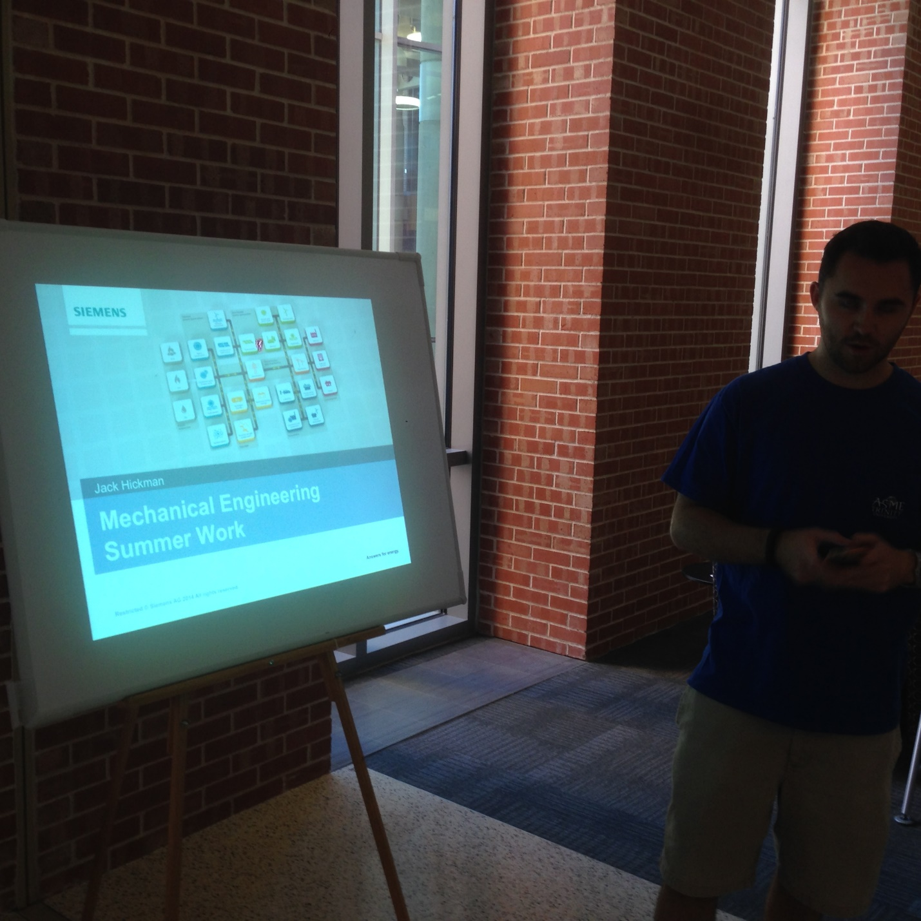

Figure 7. Visual of 900 Lumen projector with considerably less glare that was tested in a darker area of CSI 2nd floor (white background). (What’s going on over there, Jack??)

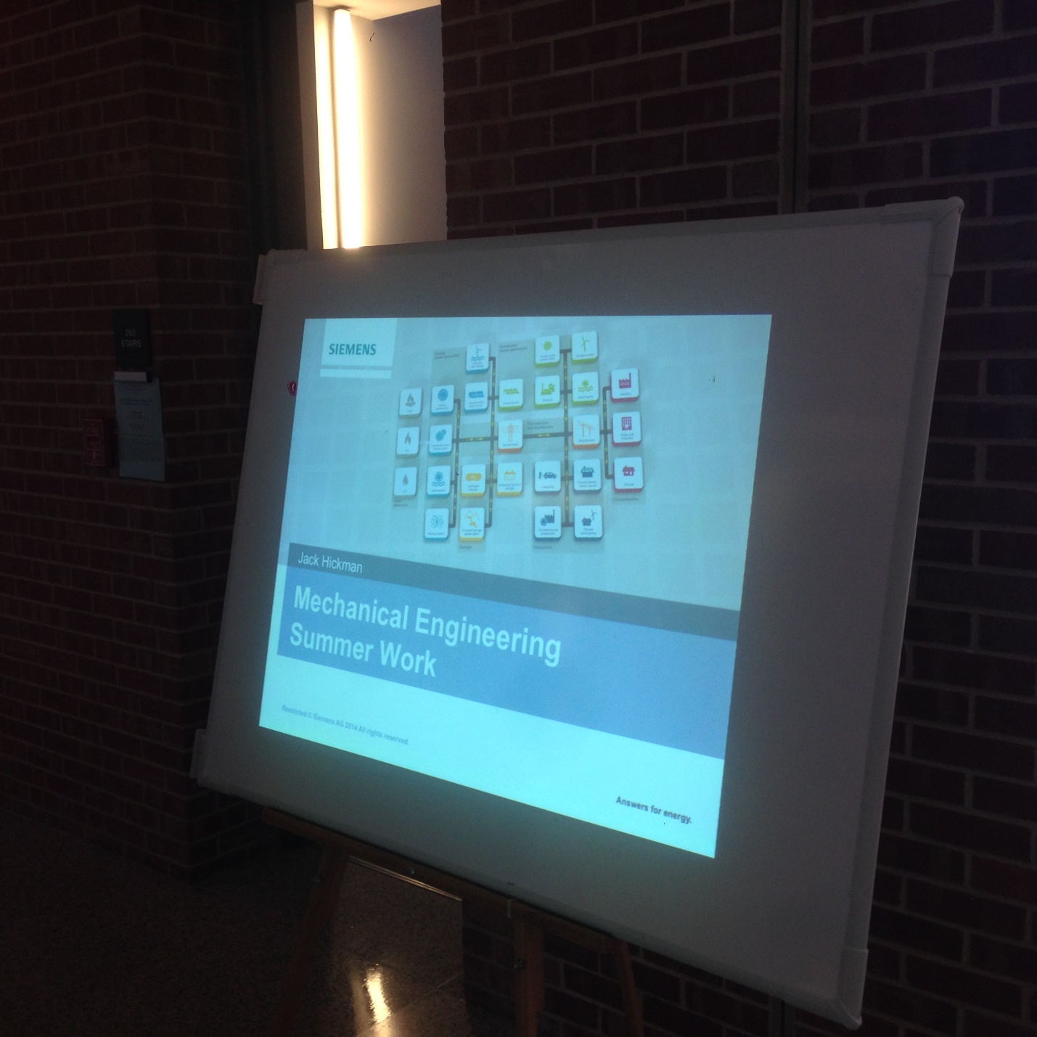

Figure 8. Visual of 900 Lumen projector with considerably less glare that was tested in a darker area of CSI 2nd floor (white background).

Comparison of the two projections of the 900 lumen projection in a brighter area (top) and a darker setting (bottom).

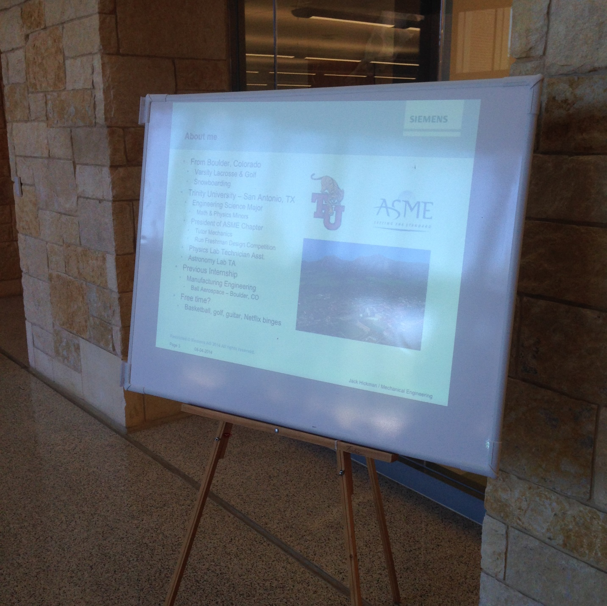

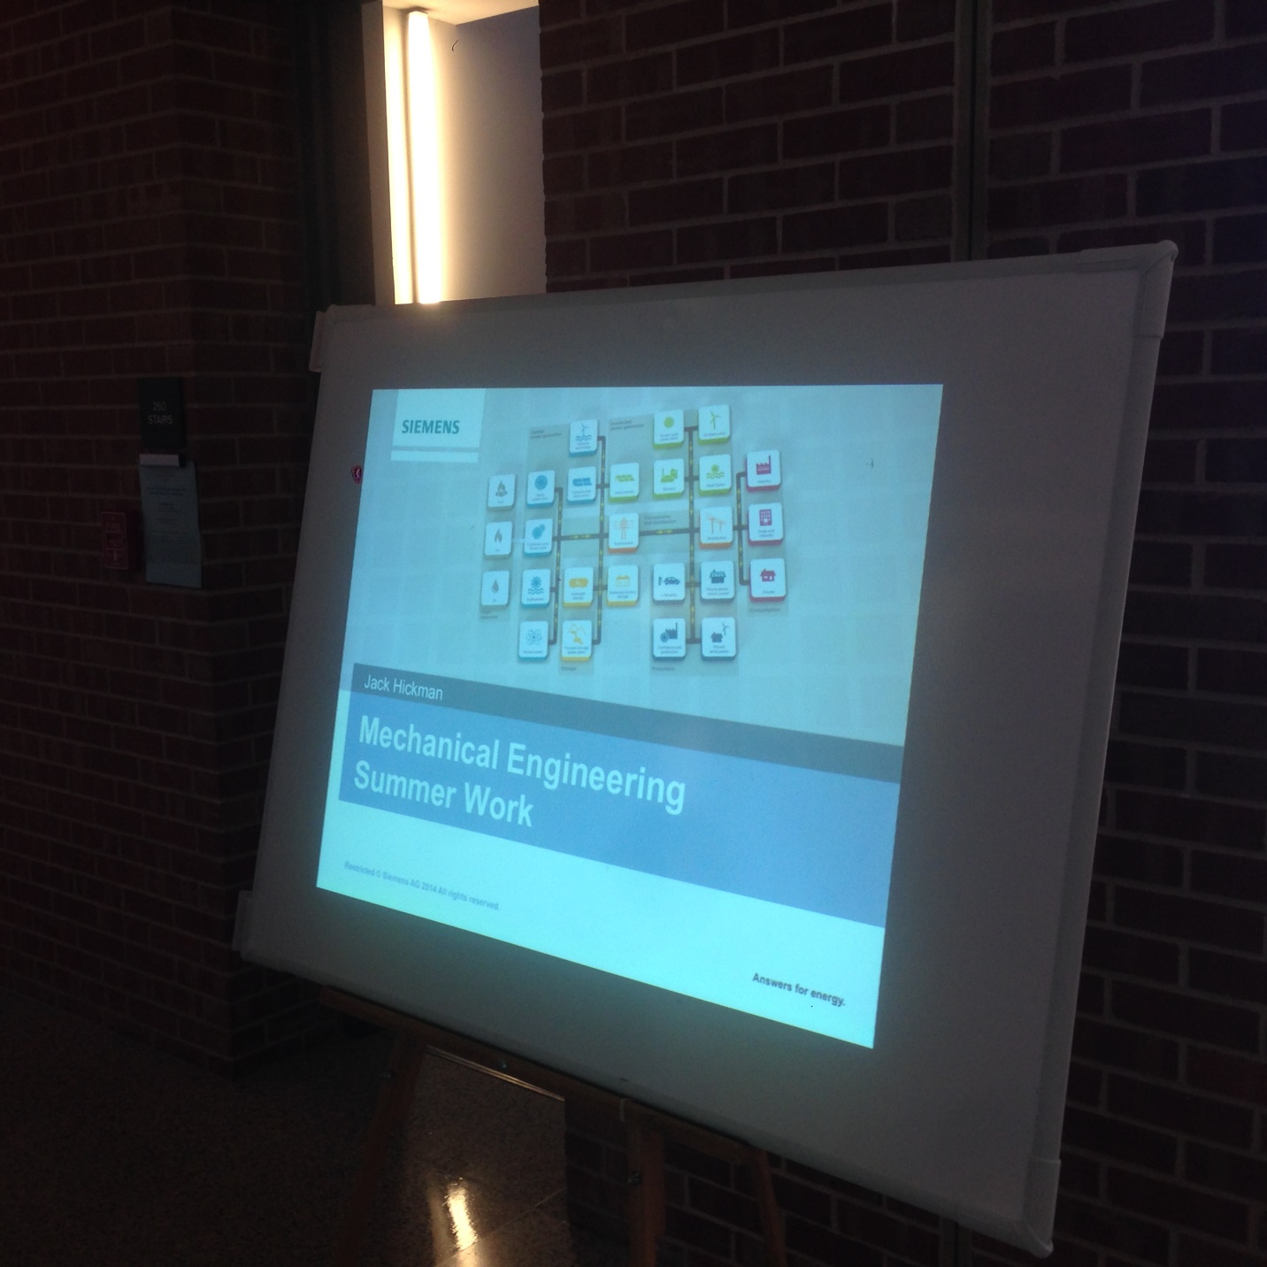

Things to take away from projector testing:

* Consider purchasing the brightest pocket projector (at reasonable cost compared to budget as a whole)
* Place white boards in darkest locations that still have an optimal view of classroom
* Utilizing a stand for the white boards
* Think of no-glare solutions to the glare issue (either purchase projector screens or if there is a no glare screen protectors)

Other questions or comments?